# CS551 - Advance Software Engineering: Lab1

- Rakesh Videm

**In Class Exercise**

A software system is to be developed for a home security system. A typical system consists of a number of sensors connected by individual circuits to a central control box containing the controller. The system receives input from entry sensors, smoke sensors, temperature sensors and flood sensors. Sensors include switches, heat detectors and motion detectors. Each sensor has an identification code which can be read by the controller to identify the sensor. The system is capable of generating alarms, turning on selected lights, and calling owner-specified phone numbers. The controller allows an operator to select which sensors are active and turn on or off the system. If a sensor is triggered when the system is active, the controller must activate the alarms (a siren and a bell) and display a message on the display panel indicating which sensor is involved. The operator must enter a security code before the system is turned on or off. The system is owner-programmable through a keypad. The owner can set thresholds for the sensors, program phone numbers and set delays for various alarms. Make reasonable assumption and clearly state them.

* 1. Create a UML class diagram for the home security system. Make sure each class is labeled with any key attributes or operations. Also include some examples of inheritance of attributes and methods to the class diagram and explain about them.

The UML class diagram for the home security system has been designed with classes having their respective attributes and methods(operations).

* Operator is himself is the owner who can set thresholds for the sensors, program phone numbers and set delays for various alarms.
* Controller is considered to be the whole security system where most of the process takes place.
* Any message from any sensor can be displayed on the display panel.
* Single alarm(siren/bell) has been used which would be triggered for any sensor.
* Temperature sensor, Smoke sensor, entry sensor and flood sensors are the inherited classes of class sensor.
* Keypad is considered to be a separate class where operations done by operator are called.



* 1. Create UML sequence diagrams to show how the program responds to an alarm being triggered, and how the operator can turn the system off.

The UML sequence diagram for the home security system has been designed as below.



**Github Account**

Sign in to Github Account with the credentials

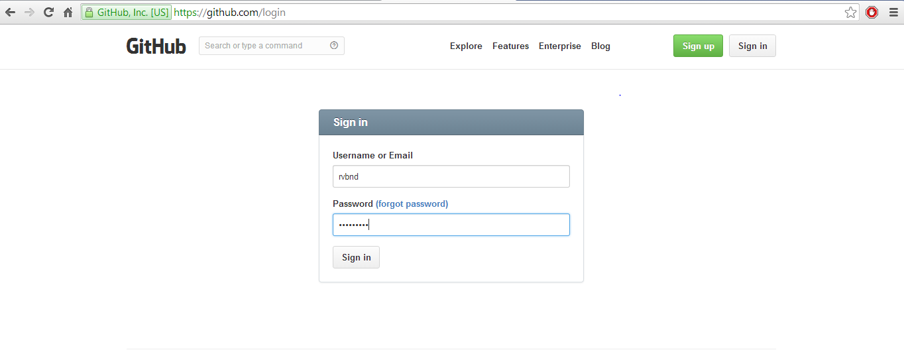

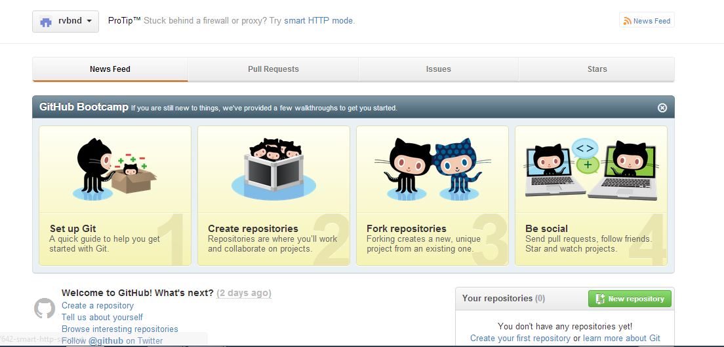

A new repository is created with the name Lab1.

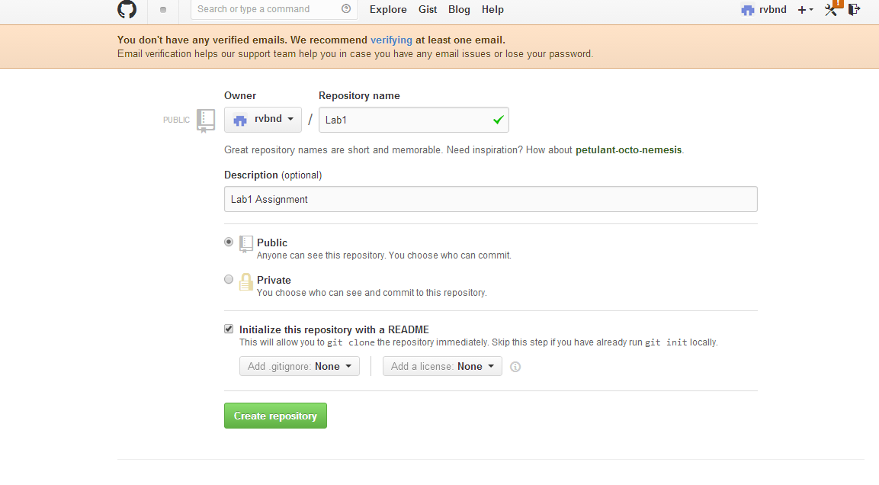

**ScrumDo**

**Story**

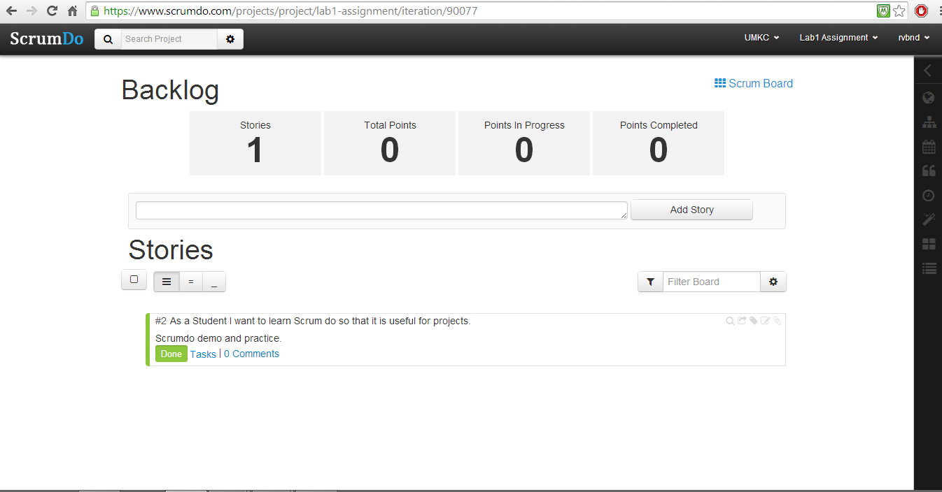

**Iteration**

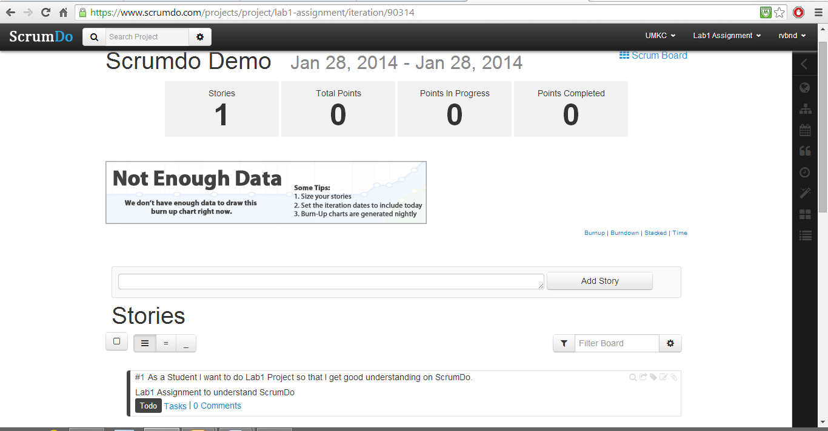

**Epic**

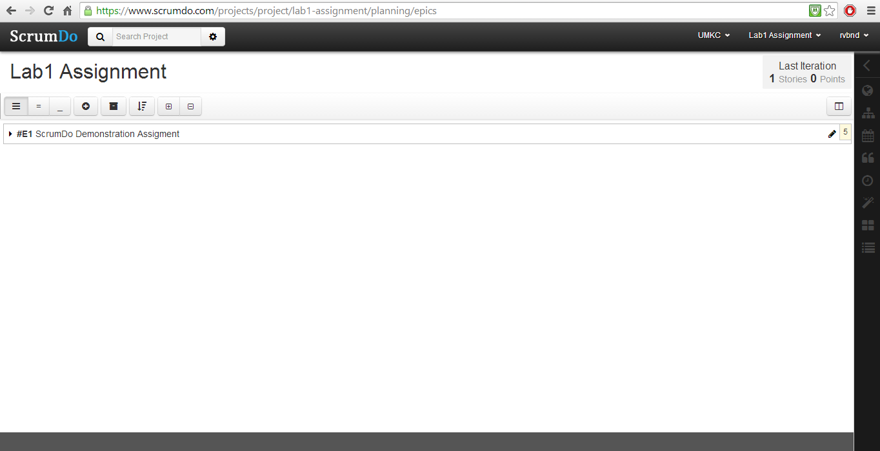

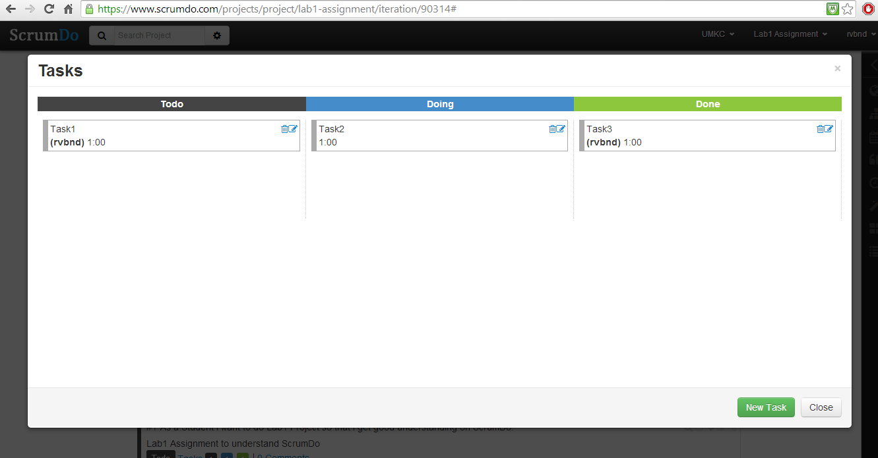

**Teams**

